Prepared Exclusively For:
Ocean Charter School

Introduction
Century Business Services (Century) headquartered in Irvine, CA with seven offices in southern California serving multiple verticals markets including Legal, Education, Manufacturing, Healthcare and others. Our group specializes in analytics, from your paper-based day to day costs, to the most core processes in your company. Whether you’re a school, small business owner, or large corporate organization, we will not only improve your current workflow, but we’ll also help you adapt to the best practices for Cost Containment, IT Services, and Document Management. We bring extensive experience and professionalism to every audit and customize our support to your individual needs and concerns and have been so for over 20 years.

Our success recently led us to be acquired by The Flex Technology Group, a $300M nationwide MPS provider. This union, backed by the private equity firm Oval Partners, has created a truly dominant MPS provider with national service coverage, unmatched resources, and combined buying power that further extends our ability to drive value for our clients. Century will remain a California based, independent business as part of this partnership and will now have resources and coverage formerly only provided by the largest manufacturers.

Flex Technology Group was designed from the ground up as a Managed Print Solutions (MPS) company. We provide customized office technology solutions for regional and national leading-edge organizations, including many multi-location organizations, manufacturers, law firms, healthcare and education/school districts among many other industries.

Century as part of Flex Technology Group is not owned by a manufacturer; we have the freedom to provide a complete suite of solutions and support to almost any manufactured product in this space. We focus on print, document management, document production, and managed IT solutions representing industry leading manufacturers such as Kyocera, Konica Minolta, Lexmark, Zebra and various software solutions. We proudly service approximately 35,000 customers.

Flex Technology Group has over 1,000 employees dedicated to Managed Print Solutions and is headquartered in Mesa, Arizona with over 40 offices across the U.S. Since our founding in 2005, we have achieved unparalleled success and growth within the industry. To illustrate our success, we have been recognized the last 12 years by Inc. 500|5000 as one of the nation’s fastest growing privately held organizations. What makes this worth mentioning is that each year this award is based on a three-year annual growth metric. If we were not providing true value to our customers year after year, we would not be able to sustain our growth and this success.

Solution

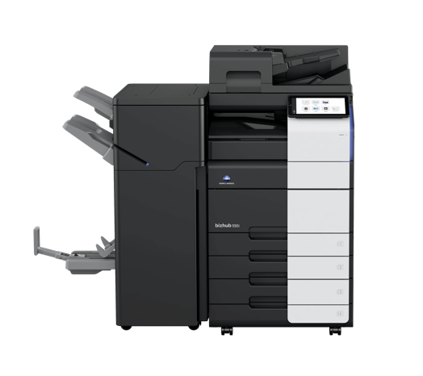

(1) Konica Bizhub 958- 90ppm B&W MFP
Includes extra paper trays, internal staple finishers

(1) Konica Bizhub C550i 55ppm Color MFP
3k Staple Finishers

(1) Konica Bizhub C550i 55ppm Color MFP
Includes extra paper trays and high stand

45,000 B&W and 4,000 Color copies per month

5 Year Fair Market Value Lease

$2,589 Per Month

B&W Pages - $.009 per page
Color Pages - $.09 per page
Unlimited Scanning Included
Includes Installation and Delivery

